**Looking for a fun, social way to get active? Look no further than AYSO Adult Soccer.**

No matter your skill level or age, AYSO Adult Soccer accommodates and welcomes all players. The program is designed to be flexible, meaning it fits the needs of the community. All interested participants have a place in AYSO Adult Soccer’s program.

Join AYSO Adult Soccer and reap the benefits today!

John Doe – Regional Commissioner

Region 123

(562) 555-1212

[JohnDoe@ayso123.com](mailto:JohnDoe@ayso123.com)

www.AYSO123.com

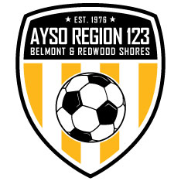

**Learn more at adultsoccer.org**